**This page has been intentionally left blank**

Note that any work that you do on this page will NOT be graded.

1. What is Moore’s Law?  
     
   _______________________________________________________________________________  
     
   _______________________________________________________________________________  
     
   _______________________________________________________________________________  
     
   Does Moore’s law still hold true?  
     
   _______________________________________________________________________________  
     
   List one effect of Moore’s law on society?  
     
   _______________________________________________________________________________

_______________________________________________________________________________

_______________________________________________________________________________

1. You are at a fundraising banquet and sitting on your table two individuals are arguing about computers and the different memory options that exist. Some of the statements that they make are listed below. First, determine which statements are false. Circle the letter next to the incorrect statements. Next, fix the **incorrect** statements in the space provided.
2. Registers are very large and very fast to access  
     
   ___________________________________________________________________________
3. Cache is slow memory that exists on the chip  
     
   ___________________________________________________________________________
4. RAM is bigger than cache   
     
   ___________________________________________________________________________
5. RAM is faster to access than data on the hard drive  
     
   ___________________________________________________________________________
6. Hard drive is on the motherboard and is very slow to access  
     
   ___________________________________________________________________________
7. Define computational thinking  
     
   _________________________________________________________________________________  
     
   _________________________________________________________________________________  
     
   _________________________________________________________________________________
8. Give an example of an object or effect that it is difficult to represent as a vector-based image. State one reason why it is difficult.

_________________________________________________________________________________  
  
_________________________________________________________________________________

_________________________________________________________________________________

1. Why is it a good idea for a company to have a vector based version of their logo?

_________________________________________________________________________________  
  
_________________________________________________________________________________

Use the scenario below to answer the next two questions. You ran into a friend from high school while shopping and she mentioned that she was interested in learning how to write computer programs and has decided to learn an assembly language. Your friend has no prior programming experience.

1. What are two reasons why learning an assembly language might be a bad idea?  
     
   _________________________________________________________________________________  
     
   _________________________________________________________________________________

_________________________________________________________________________________

1. What other type of programming language would be a better choice for your friend to learn?

_________________________________________________________________________________

1. What is unconscious bias?

_________________________________________________________________________________  
  
_________________________________________________________________________________

1. In class we discussed the situation at Facebook involving trending topics, give an example of unconscious bias that may have existed.

_________________________________________________________________________________  
  
_________________________________________________________________________________

_________________________________________________________________________________

Use the scenario to answer the next four questions. As a manager of an exclusive clothing boutique you are tasked with instructing store employees on the best way to arrange store items. The clothing needs to be arranged by designer (alphabetically) and then by item price (ascending order). The exclusive nature of the boutique and the clientele that you cater too necessitates that the store be optimized for customer comfort. To make this possible, the space in the store for employees to arrange and sort through clothing items is limited.

1. In class we discussed a series of sorting algorithms, if the employees were familiar with the simple and insertion sort algorithm, which algorithm would you recommend that they use and why would you recommend that algorithm?

_________________________________________________________________________________  
  
_________________________________________________________________________________  
  
_________________________________________________________________________________

________________________________________________________________________________

1. If an employee was sorting 10 clothing items, on average, how many comparisons are needed using the Selection Sort algorithm discussed in class?  
     
   __________________________________________________________

1. If an employee was sorting 10 clothing items, on average, how much space (i.e., memory slots) is needed to sort the items when using the Simple Sort algorithm discussed in class?  
     
   _________________________________________________________
2. One of the other supervisors had previously given the employees instructions (i.e., algorithm) for arranging the items, but the instructions only worked for shirts, it did not work for skirts. Which computational building block did the supervisor’s algorithm violate?

_________________________________________________________________________________

1. Explain the difference between unambiguous and ambiguous tasks and give an example of each type of task.

Unambiguous - _______________________________________________________________________  
  
____________________________________________________________________________________  
  
____________________________________________________________________________________  
  
____________________________________________________________________________________

Ambiguous - _________________________________________________________________________  
  
____________________________________________________________________________________  
  
____________________________________________________________________________________  
  
____________________________________________________________________________________

For the number conversion problems, Write the answer in the space provided. Use the provided extra sheet for your rough work. The conversion table exists on the last page of the exam.

1. Convert 0x10A to decimal  
     
   _________________________________________________________________________________
2. Convert decimal 202 to hexadecimal  
     
   ________________________________________________________________________________
3. Convert decimal 157 to binary  
     
   _________________________________________________________________________________
4. Convert 0b10101111 to decimal  
     
   _________________________________________________________________________________
5. Convert 0b1111000100 to hexadecimal  
     
   _________________________________________________________________________________
6. What image is represented by the following sequence?  
   4,0, 2,3, 2,1, 4,0

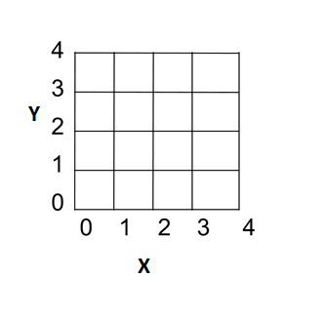

For the following snap programs when asked **What does the sprite say when this program is run?,** you do not need to indicate the number of seconds the message is displayed on the screen. Just write down the message in the space provided.

1. What does the sprite say when this program is run?

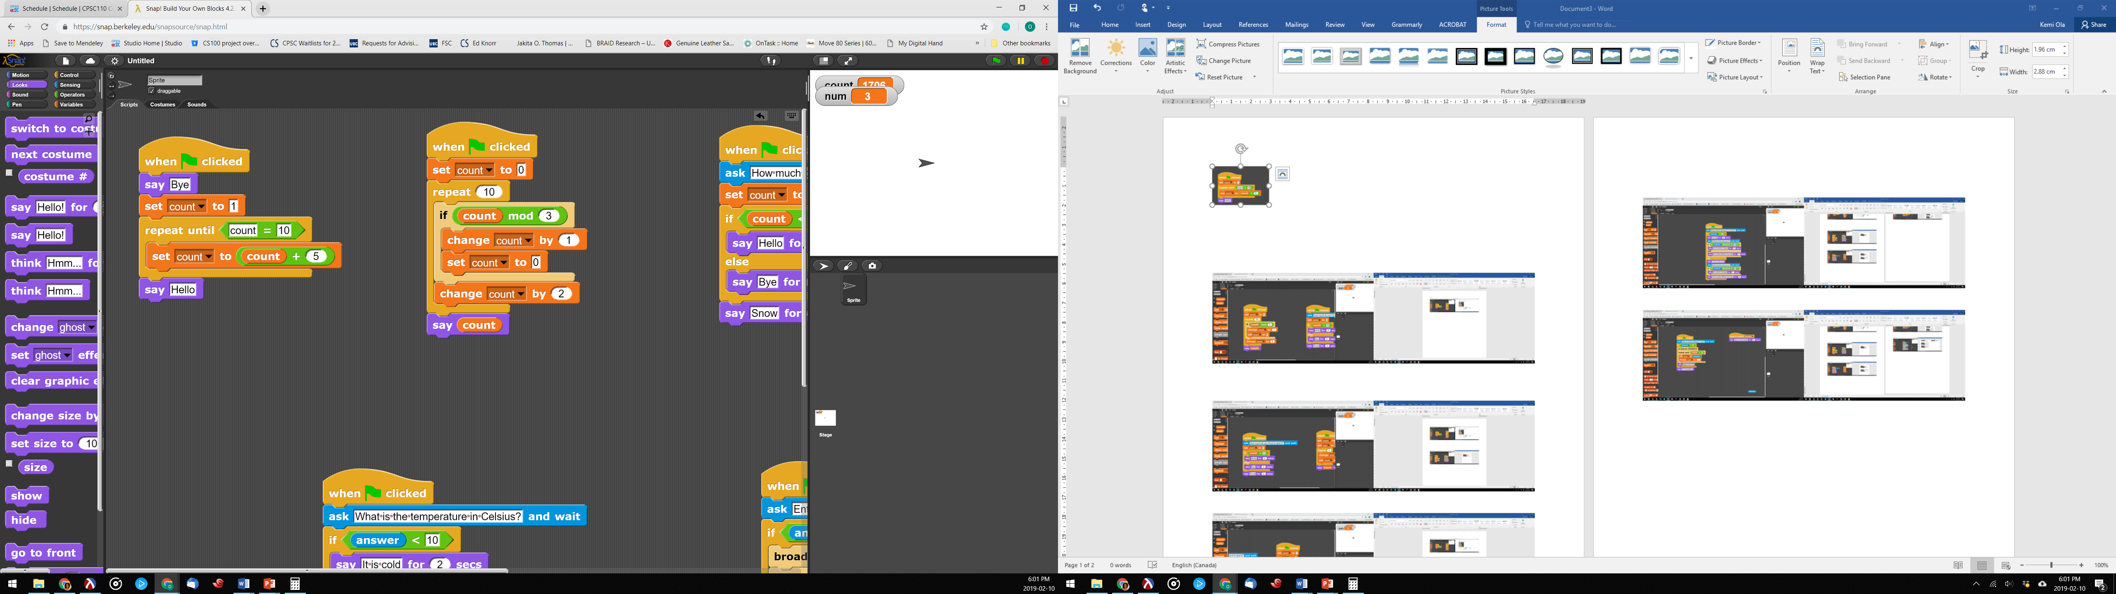

________________________________________  
  
  
________________________________________

________________________________________

1. If the user input is 5, what does the sprite say when this program is run?

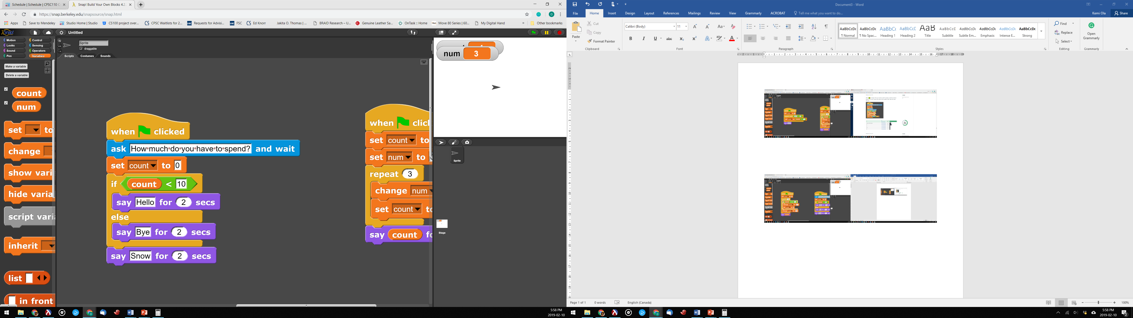

________________________________________  
  
  
________________________________________  
  
  
________________________________________

1. What does the sprite say when this program is run?

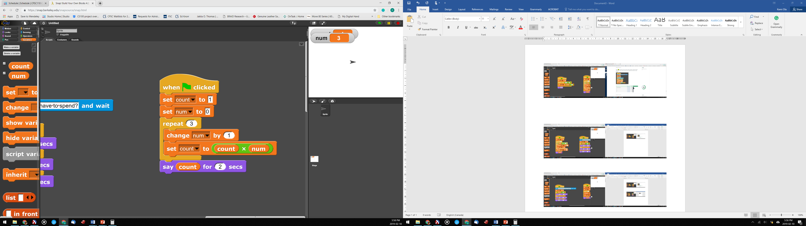

________________________________________  
  
  
________________________________________

________________________________________  
  
  
________________________________________

1. For the given input what does the sprite say when the program is run? Fill in the table for each input

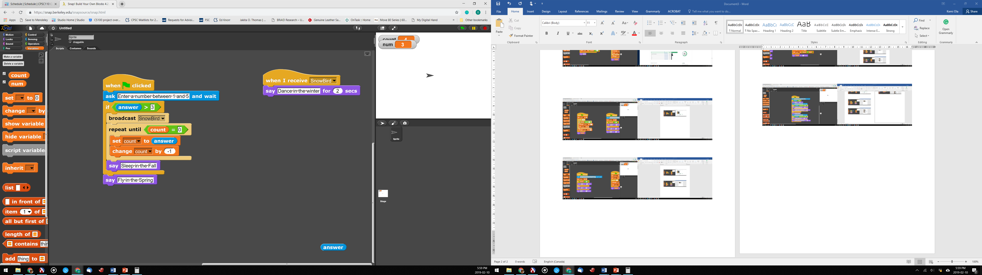

|  |  |
| --- | --- |
| **Enter a number between 1 and 5?** | **Output** |
| 4 | ______________________________  ______________________________ |
| 2 | ______________________________  ______________________________ |

1. For the given input what does the sprite say when the program is run? Fill in the table for each input

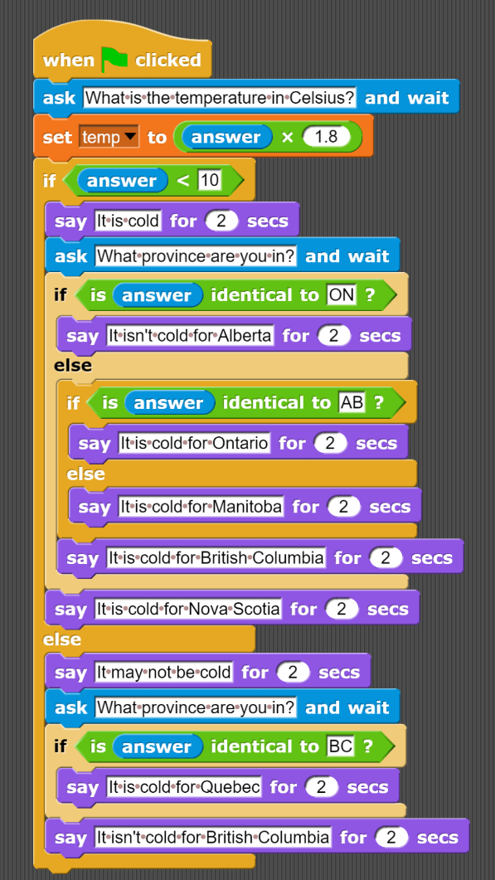

|  |  |  |
| --- | --- | --- |
| **What is the temperature in Celsius?** | **What province are you in?** | **Output** |
| 5 | AB | ________________________________________________________  ________________________________________________________  ________________________________________________________  ________________________________________________________ |
| 15 | BC | ________________________________________________________  ________________________________________________________  ________________________________________________________  ________________________________________________________ |

1. As a photographer for the Canadian Broadcasting Company, you constantly find yourself taking pictures, all around the country. Currently you are trying to determine which compression to use so that you can send the pictures to your boss. If you wanted to preserve the original quality of the image which bitmap compression should you use and what is the limitation of your chosen compression?

_______________________________________________________________________________________  
  
_______________________________________________________________________________________  
  
_______________________________________________________________________________________  
  
_______________________________________________________________________________________

1. As an employee of an advertising agency, you are tasked with developing a classifier that will correctly determine if a potential Super bowl ad will be considered controversial or not. You have data that includes all the past ads for your company and whether or not they were controversial. List the steps that you need to engage in, in order to create the classifier. You are not required to write out the algorithm or create the classifier, just list the steps for creating a classifier.

_______________________________________________________________________________________________  
  
  
_______________________________________________________________________________________________  
  
  
_______________________________________________________________________________________________

_______________________________________________________________________________________________  
  
  
_______________________________________________________________________________________________

_______________________________________________________________________________________________  
  
  
_______________________________________________________________________________________________

1. As a painter you are in the habit of using a color palette that clearly states each color. You are now working on a project that requires you to work with the hex representation of each color. In order to make your work progress seamlessly you decided to create a cell phone app that consumes a hex color and produces the color palette equivalent. For instance, if your app is given the hex code **#F109DF**, it should produce **“a shade of purple”**. Create an algorithm that reads in a hex code and produces the color palette shade. Assume that you have a lookup table stored on your phone that details the combination of primary colors. A snippet of the table is shown below

|  |  |  |
| --- | --- | --- |
| Primary Color 1 | Primary Color 2 | Result |
| Red | Blue | Purple |
| Red | Green | Yellow |
| … |  |  |

Note: you are not asked to complete the lookup table. The full lookup table already exists on your phone.

_______________________________________________________________________________________  
  
______________________________________________________________________________________  
  
_______________________________________________________________________________________  
  
_______________________________________________________________________________________  
  
_______________________________________________________________________________________  
  
_______________________________________________________________________________________  
  
_______________________________________________________________________________________  
  
_______________________________________________________________________________________  
  
_______________________________________________________________________________________  
  
_______________________________________________________________________________________  
  
_______________________________________________________________________________________  
  
_______________________________________________________________________________________

_______________________________________________________________________________________  
  
_______________________________________________________________________________________  
  
_______________________________________________________________________________________

Use this sheet for work that you want graded. Make sure you clearly state which question(s) you are answering on this page.

_______________________________________________________________________________________  
  
______________________________________________________________________________________  
  
_______________________________________________________________________________________  
  
_______________________________________________________________________________________  
  
_______________________________________________________________________________________  
  
_______________________________________________________________________________________  
  
_______________________________________________________________________________________  
  
_______________________________________________________________________________________  
  
_______________________________________________________________________________________  
  
_______________________________________________________________________________________  
  
_______________________________________________________________________________________  
  
_______________________________________________________________________________________

_______________________________________________________________________________________  
  
_______________________________________________________________________________________  
  
_______________________________________________________________________________________

_______________________________________________________________________________________  
  
_______________________________________________________________________________________  
  
_______________________________________________________________________________________  
  
_______________________________________________________________________________________  
  
_______________________________________________________________________________________

_______________________________________________________________________________________

**Information you may find useful. This sheet will NOT be graded.**

|  |  |
| --- | --- |
| Powers of two | Hexadecimal digits |
| |  |  | | --- | --- | | 2 raised to the power of |  | | 0 | 1 | | 1 | 2 | | 2 | 4 | | 3 | 8 | | 4 | 16 | | 5 | 32 | | 6 | 64 | | 7 | 128 | | 8 | 256 | | 9 | 512 | | |  |  | | --- | --- | | Binary Representation | Hexadecimal representation | | 0000 | 0 | | 0001 | 1 | | 0010 | 2 | | 0011 | 3 | | 0100 | 4 | | 0101 | 5 | | 0110 | 6 | | 0111 | 7 | | 1000 | 8 | | 1001 | 9 | | 1010 | A | | 1011 | B | | 1100 | C | | 1101 | D | | 1110 | E | | 1111 | F | |

**This page has been intentionally left blank**

Note that any work that you do on this page will NOT be graded.